Lab 10 Report

Jonathan Westerfield

224005649

4/10/18

Objective:

The purpose of this lab is to characterize N and P type metal-oxide-semiconductor field-effect transistors (MOS-FETs), also known as NMOS and PMOS transistors.

Introduction:

First, we build the circuits in Multisim to give us a rough estimation on what the values should be and then graph using the data accordingly. Then, we go through and build each circuit. To measure this, we simply look at the scope, output the values to excel and plot our graphs.

Simulation Plots

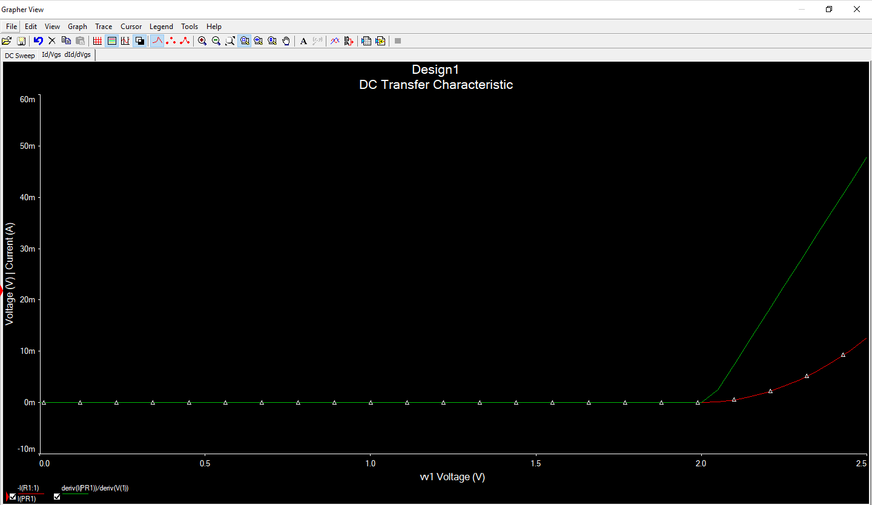

VT = 2 V

β = 0.08

Experimental Plots

NMOS 2700 Id vs Vgs

NMOST 2700 *d*Id vs *d*Vgs

VT = 2 V

β = 17.021

NMOS CD4007 Id vs Vgs

NMOS CD4007 *d*Id vs *d*Vgs

VT = 1.5 V

β = 374.935

PMOS CD4007 Id vs Vgs

PMOS CD4007 *d*Id vs *d*Vgs

VT = 2 V

β = 1043.906

Conclusion:

My simulations were very close to my experimental measurements. Any deviations between the 2 can be attributed to extra resistances built into the breadboard.